Hey Will,

Hope everyone at home is doing well! My trip has been a lot of fun – what do you think of my pictures?

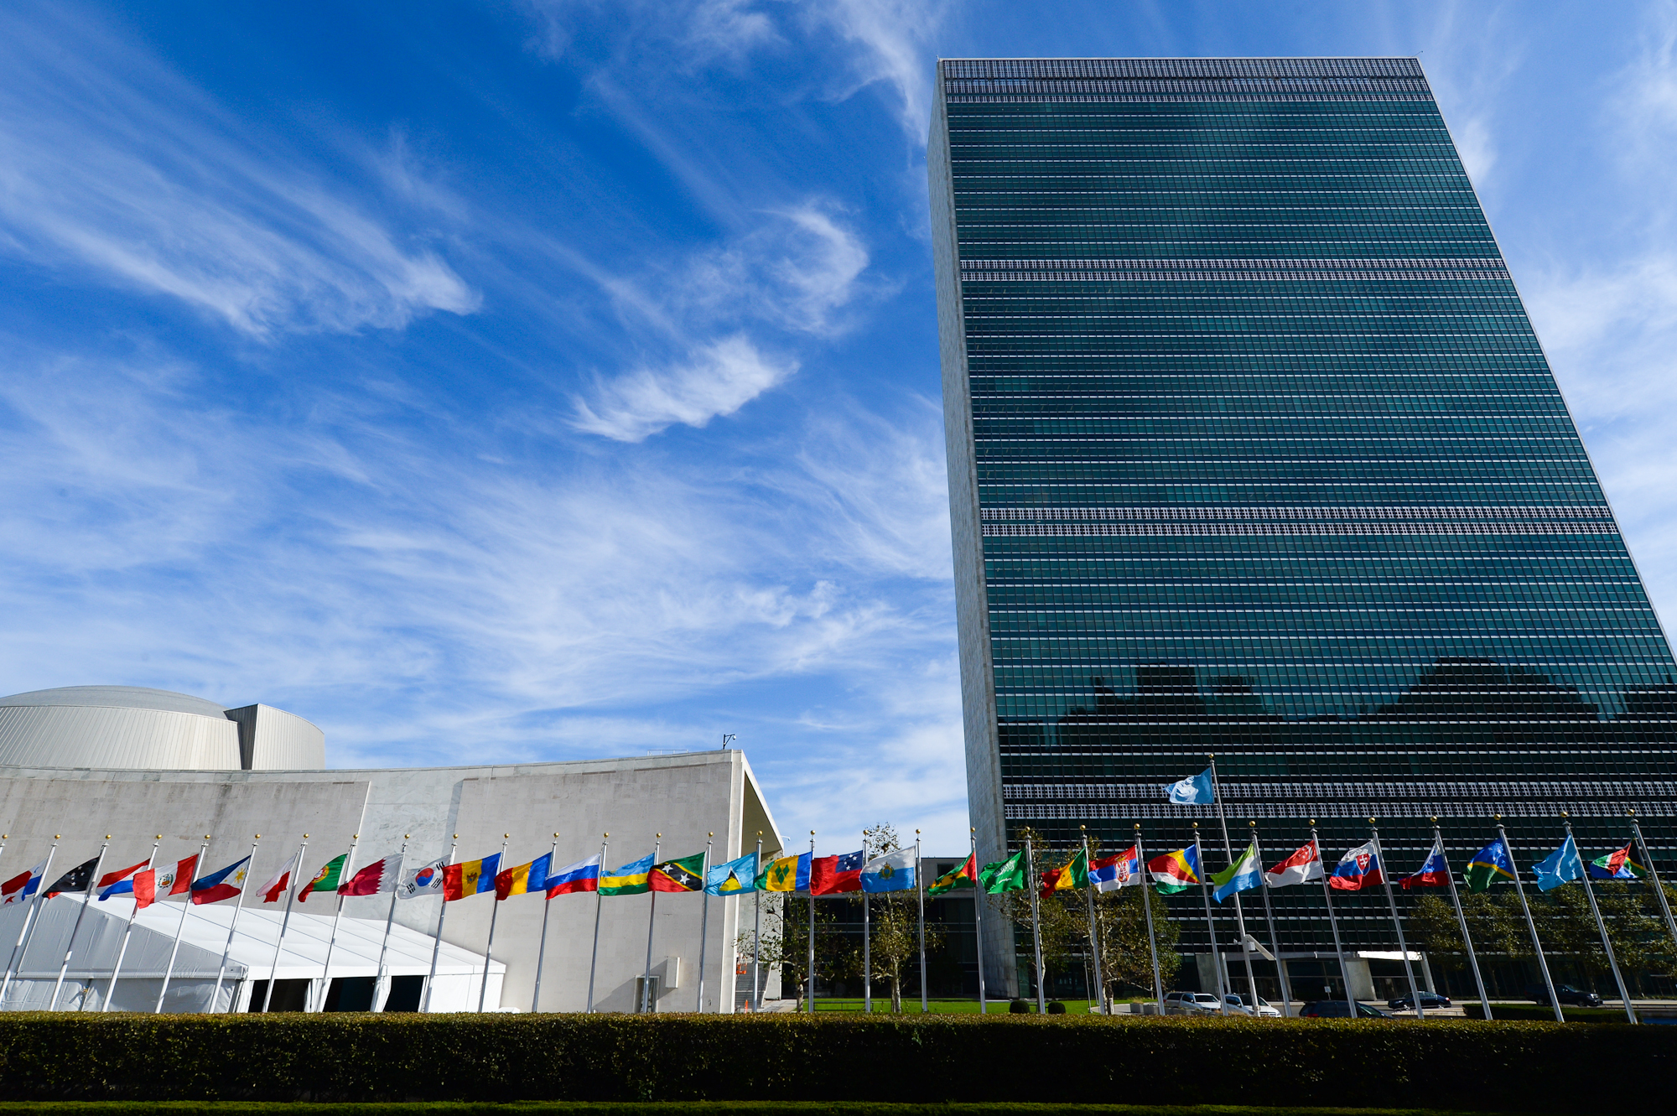

Best,

Bill